САПАРОВА Перизат Мухтаровна,
№131 жалпы орта білім беретін мектебінің ағылшын тілі пәні мұғалімі.
Шымкент қаласы

JOBS

Learning objectives(s) that this lesson is contributing to | 5.1.2.1- use speaking and listening skills to provide sensitive feedback to peers;  5.2.5.1- understand most specific information and detail of short, supported talk on a wide range of familiar topics;  5.3.2.1- ask simple questions to get information about a limited range of general topics;
Lesson objectives | All learners will be able to:  - answer for simple questions  - learn vocabulary for jobs.  Most learners will be able to:  - categorize jobs.  - talk about jobs I would like.  Some learners will be able to:  - understand most specific information and detail of short  Learners will be able to recognize new vocabulary words, know about names of professions and ask and answer questions about a job
Lesson plan
Planned timings | Teacher's actions | Students` actions | Assessment | Resources
ORGANISATION MOMENT  5 minutes | Teacher greets students  Teacher: Good morning!  How are you?  Welcome to our English lesson  Ok, if you are ready let’s start our lesson  What was your home task?  T ask to answer a few questions about Batyrkhan Shukenov using QR code. | Students respond to greeting and take their places  Learners answer the question ‘How are you?’  S answer to read the text about Batyrkhan Shukenov  Learners answer the questions using QR codes. | Formative assessment  By the method of “Thumb”    ‘excellent’  ‘well done’  ‘good job’ | Books  Copybooks  Interactive white board  QR code,  mobile phone
MAIN PART  35 minutes | Dividing into groups with cards “Jobs”  The 1st group -Singers    The 2nd group- Actors    Teacher give some examples then ask students what they think is the topic of today’s lesson.  Listening  New words:  Pilot-|ˈpaɪlət|-ұшқыш  Mechanic-|mɪˈkænɪk|-механик  Factory worker-|ˈfækt(ə)rɪ||ˈwɜːkə(r)|-зауыт жұмысшысы  Businessman/woman- |ˈbɪznɪsmən|/|ˈbɪznɪswʊmən| -іскер адам, әйел  Photographer- |fəˈtɒɡrəfə|-фотограф  Actor-|ˈæktə|-актер  Chef- |ʃef|-аспаз  Receptionist-|rɪˈsepʃ(ə)nɪst|-хатшы  Reading  Exercise 1  Teacher shows the new words and ask students spell it then match the words with the pictures    Speaking  Exercise 2  Teacher calls one student to the board and ask them to imagine themselves 20 years later, then ask the students to ask him questions  Dynamic pause . Warm up  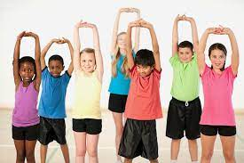  By the method “How to speak our body?”  Reading and writing  Group work  Exercise 3  Teacher gives posters to each group and ask them to write which job works where and how?  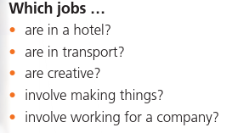  Game “Find the gifts”  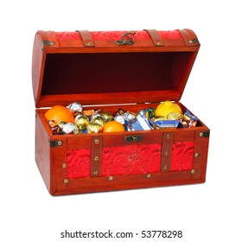The teacher says that she has a gift for the students, to take the gift asks to open the envelopes hidden all over the class .At the end of game, teacher gives the students the sweets they found. | Students go to the board and choose cards with the image of actors and singers and everyone should say who he or she is by profession. Then who chose the actor go to the group of actors, who chose the singer go to the group of singers.  Students guess the theme and answer the question  Pupils should listen to and repeat after the teacher and try to learn by heart the new words of today’s lesson  Pupils should look again to the pictures attentively. Ask permission to answer then spell the word that shows teacher and match the words with the picture on the board.  Student in the board closes his eyes and imagines himself in 20 yers later and ansew the questions of other students.  Students ask questions  1.How old are you?  2.What’s your job?  3.Do you like your job?  Students stand up and answer questions and do exercises at the same time.  Pupils should read and write sentences on the poster, then show it and read and translate.  Students should find the envelopes hidden through the classroom and translate the words from the envelopes. | ‘super’  ‘brilliant’  ‘very well’  By the method of “Dollars  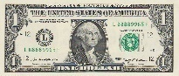  By the method of  ‘COMPLIMENTS’  ‘BRILLIANT’  ‘GOOD JOB’  ‘WELL DONE’  By the method of “Dollars”  1-2 points  By the method of ‘Dollars’  1-2 points  ‘super’  ‘brilliant’  ‘very well’  Formative assessment  By the method of “Dollars”  By the method of “STARS”  1-2 points  By the method of  ‘COMPLIMENTS’  ‘BRILLIANT’  ‘GOOD JOB’  ‘WELL DONE’ | Cards with actors and singers pictures  Interactive  White boards  Laptop  Cards  Blackboard  Pictures of professions  Laptop  Music  Posters  glue  cards  Blackboard  Gifts, box,  envelopes
ENDING THE LESSON:  5 minutes | Reflection  Well what do you think about today’s lesson?  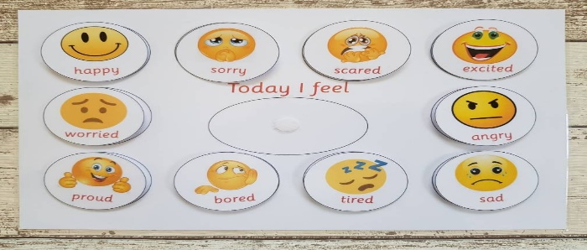  Give the home task  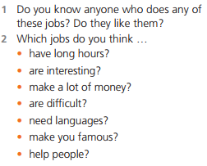  Say Good bye | Students chose emoticons on the interactive whiteboard if they like the lesson choose good if they don’t like it then sad emoticons.  If they don’t understand or have questions they can write comment on instagram  Pupils should write about 4-5 sentences  Children say Good bye | Feedback | Interactive  White board  Picture of Instagram  Stickers

